Monday December 26th St Stephen
Mass: 10am SJV

Tuesday December 27th St John
Masses: 10am SJV; 10am OLA

Wednesday December 28th Holy Innocents
Masses: 10am SJV; Noon St.C

Thursday December 29th St Thomas Beckett
Masses: 10am SJV; 10am OLA

Friday December 30st The Holy Family
Masses: 10am SJV; Noon St. C.

Saturday December 31st Seventh Day of Christmas
Masses: 5.30pm SJV; 6pm OLA
Neo-catechumenal Eucharist 6.30pm SJV.

Sunday January 1st Mary, Mother of God
Masses: 9am SJV; 10am St C; 10.30am OLA; 11.15 SJV
Polish Mass 3.30pm St C; Syro-Malabar Mass 5.30pm SJV

Abbreviations: SJV – St John Vianney, St C – St Cuthbert’s
OLA – Our Lady of the Assumption

The Parish of Guardian Angels, Blackpool
Incorporating: St John Vianney, St Cuthbert
& Our Lady of the Assumption.
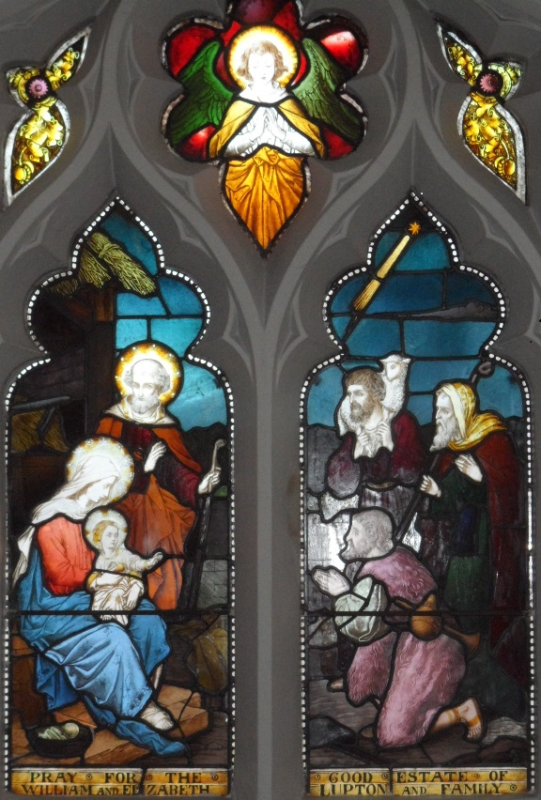

Nativity Window St Cuthbert’s Church

The Priests of the Parish
Wish you a
Very Holy Christmas and a
Blessed New Year

Sunday December 18th
Fourth Sunday in Advent:
Masses (Vigil Sat) 5.30pm: SJV; 6pm: OLA
Sunday: 9am: SJV; 10am St C; 10.30am OLA; 11.15 SJV; 3.30pm Vespers & Benediction SJV
Polish Mass 3.30pm St C; Syro-Malabar Mass 5.30pm SJV

Monday December 19th
Mass: 9.15am SJV

Tuesday December 20th
Masses: 9.15am SJV; 9.30am OLA

Wednesday December 21st
Masses: 9.15am SJV; Noon St C
11am Requiem SJV Arthur Williamson

Thursday December 22nd
Masses: 9.15am SJV; 9.30am OLA

Friday December 23rd
Masses: 9.15am SJV; Noon St. C.

Saturday 24th December Christmas Eve
Masses: for Christmas: 5.30pm SJV; 6pm OLA
Syro-Malabar Mass 10pm SJV

Sunday 25th December Christmas Day
Masses: 9am SJV; 10am St C; 10.30am OLA & 11.15 SJV
Polish Mass 3.30pm St C

